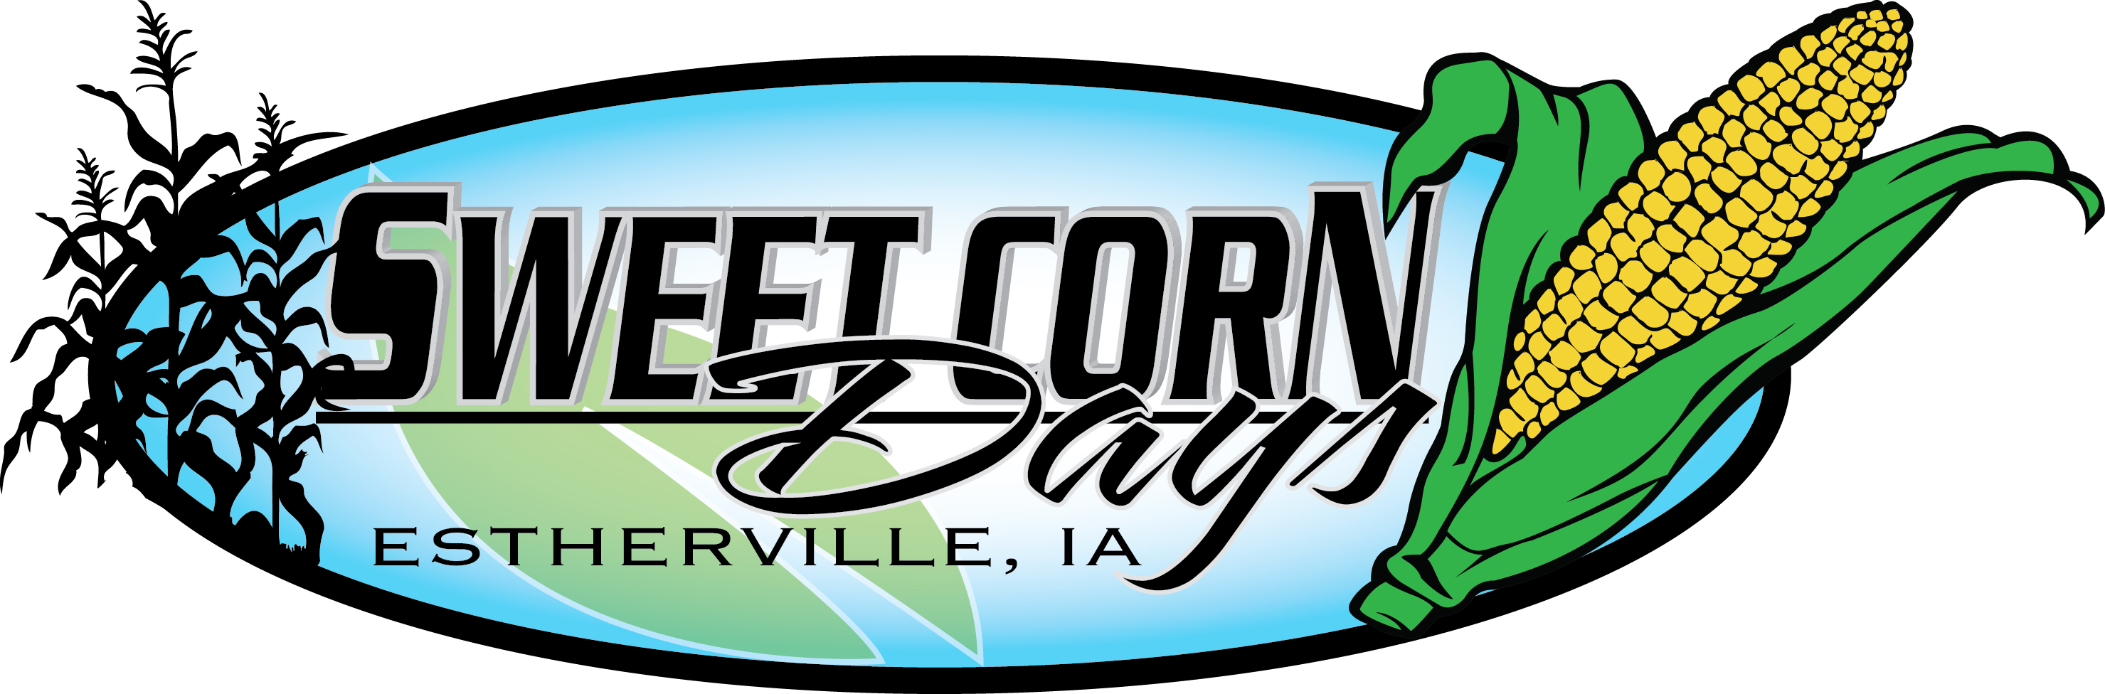
Little Miss & Mister Sweet Corn Pageant
Participant Registration and Entry Form

The 11th Annual Little Miss & Mister Sweet Corn Pageant will be hosted by Envy Salon on Friday, August 3, 2018. All Estherville area girls and boys ages 4-8 are welcome. Only the first 24 kids registered will be accepted. No registrations before July 13, 2018 or after July 23, 2018 will be accepted.
Participation in the pageant entails:
- Judging will be held on Friday afternoon at the Estherville Public Library interviews last approximately 10 minutes.
- The pageant will be held in Library Square at 5:30pm Friday evening.
- All participants will get the opportunity to ride on a float in the Sweet Corn Days Parade on Saturday, August 4, 2018.
More information will be available after registration. Any questions can be answered by Envy Salon at 712-362-0041 or by the Estherville Area Chamber of Commerce at 712-362-3541.

Participants Name_______________________________________ Age__________________________
Date of Birth_______________ Parent’s Names_____________________________________________
Gender____________________ Phone Numbers: Home______________ Cell____________________

Parent Signature _____________________________________________________________________

Please bring filled out registration forms to Envy Salon at 610 Central Avenue.

